

EPA ToxCast Challenge
LELPredictor



Scott Norin (RigelFive) – Hudson Ohio USA
rigelfive@gmail.com
14 - 28 May 2014

I. Problem Statement
The EPA created a tool to predict the toxicity of new man-made chemicals and passed a proof-of-concept phase in 2009. This tool utilized chemical toxicity data from over 30 years which comprised over $2 billion in animal testing. One of the parameters to be calculated from this test includes the Lowest Effect Level (LEL), which is the lowest dosage of the chemical that shows adverse effects in animals.

The goal of the TopCoder / EPA ToxCast Challenge is to build an algorithm using the data provided to predict a chemical's systemic -log(LEL) value. This prediction tool is to provide significant value through saving an extensive amount of time, money and quality of life for animals in performing these tests. The data provided for the challenge includes in vitro assays, chemical properties and chemical structural descriptors.

II. Requirements
A set of atomized requirements were generated to assist in the formulation of the LELPredictor algorithm. The essential requirements for the tool were to:
1) read input data provided,
2) perform numerical computations to determine the correlation from a specific set of intrinsic parameters with the LEL value,
3) output the predicted LEL values into an array to be scored by the TopCoder website.

III. Design Decisions
Three methodologies were attempted to maximize the score for the ToxCast challenge. The focus of this tool was to utilize intrinsic parameters such as molecular weight rather than attempting to correlate extrinsic parameters such as AC50 or -log(LEL). The three approaches attempted include :

1) Utilize the freeware Python-based code RDKit to determine the intrinsic parameters of TPSA, max Q, min Q, log P and molecular weight.
2) Utilize values provided in the data set including a count of the chemical's atoms, bonds, chains, groups, rings and molecular weight.
3) Utilize a single intrinsic parameter associated with the chemical's size which is a function of the molecular weight.

Through processing of the data files, the RDKit tool was unable to process all of the SMILES format chemical structures that were provided in this competition. While, the RDKit tool was able to calculate intrinsic parameters for some of the chemicals, individual tailoring of the chemical input was not able to be completed in time to achieve the competition deadline.

The topological polar surface area (TPSA) is a value that helps to assess the ability of a molecule to permeate through cells based on the surface area . Max Q and min Q are values that quantify the electronic charging typically seen with a molecule. The value of log P provides an indirect assessment of a molecule to be in solution versus act as a condensed solid. Each of these values are typically used with informatics methodologies to determine a molecules characteristic behavior.

The final algorithm generated by approach #3 utilized the input value of molecular weight and had better correlation statistics than what was determined in approach #2 that used inputs of atoms, bonds, chains, groups, and rings that was provided in the data set.

While the approach used is over simplified, it is difficult to derive extrinsic properties of adjacent chemicals by any method and have a high confidence that would offset the necessary EPA testing.

IV. Software Architecture
The main methods used to generate the -log(LEL) values are generated using classes shown in the UML2 block definition diagram in Figure 1. The LELPredictor tool utilizes code that is grouped into three categories:

1) data structures to handle the chemical data,
2) classes to read data provided for the TopCoder EPA ToxCast competition,
3) a neural network classes that are used to minimize the error of a unique curve fit through a loosely correlated set of data.

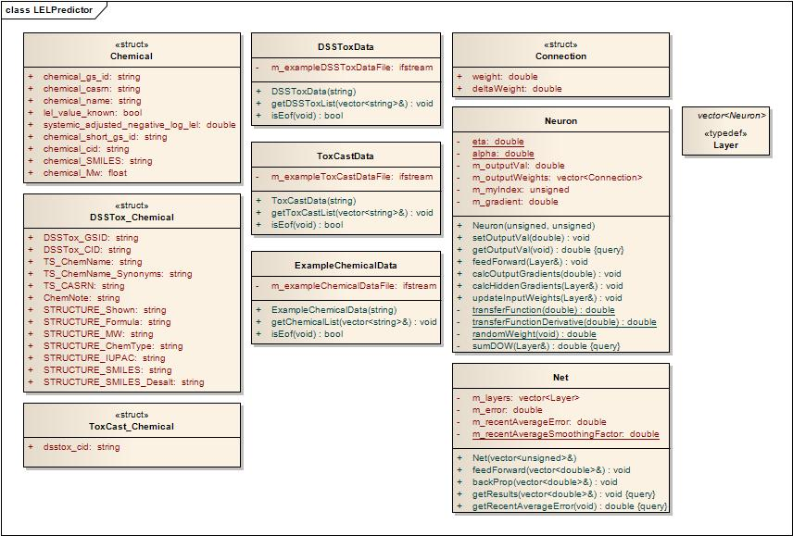
Figure 1 – Block Definition Diagram for the RigelFive LELPredictor

The algorithm that was finally developed utilized a single parameter input which was the value of molecular weight. The known -log(LEL) values from a set of chemicals were used with the molecular weight parameter to train a small multi-layer perceptron (MLP) neural network. The trained neural network was used with an adjacent set of chemicals where the -log(LEL) value is unknown. The neural network code used was based off of the publicly available tutorials by David Miller at the following link: http://www.millermattson.com/dave/?p=54

The topology of the neural network used to estimate the -log(LEL) value is shown in Figure 2. The neural network utilized a parabolic filter to normalize the input values and a parabolic amplifier function to generate the output values. The parabolic amplifier was defined using the provided chemical data in the ToxCast data files (those with LEL values known). The equations for the parabolic filters and amplifier are provided in Appendix C.

The correlation of molecular weight to the estimated -log(LEL) value is shown in Figure 3.
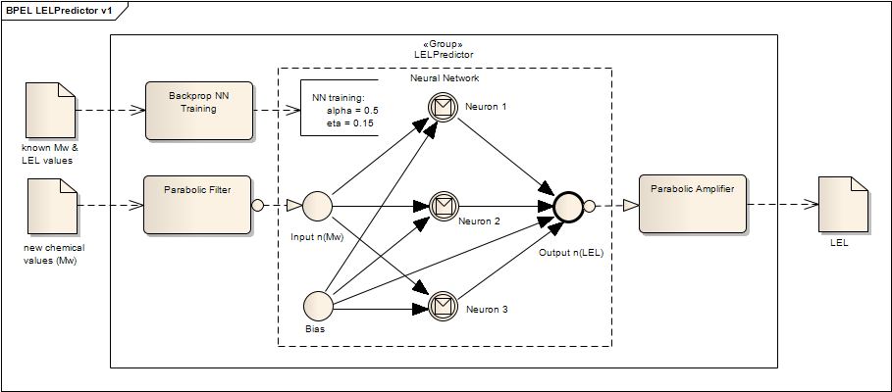
Figure 2 – High Level Architecture Used for the LELPredictor Tool

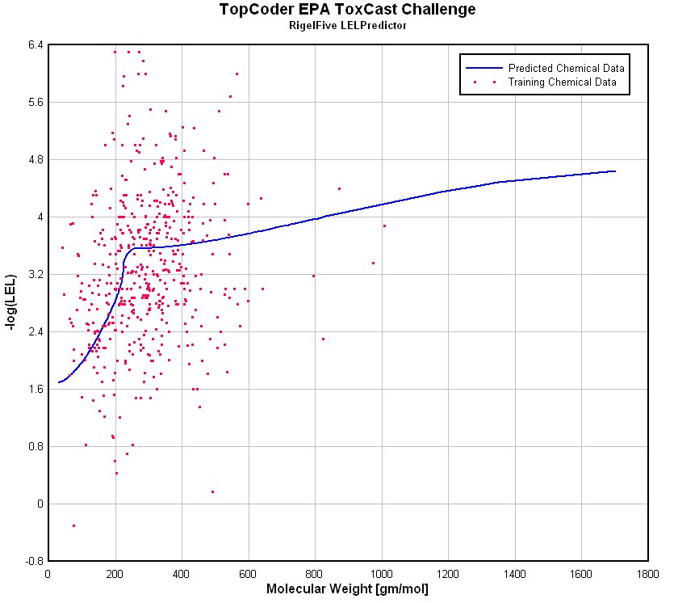
Figure 3 – Correlation Determined using the RigelFive LELPredictor

Conclusions
An estimation of the -log(LEL) value was fit to known data that has a low level of correlation to a single parameter. This low correlation is attributed to the -log(LEL) value being an extrinsic parameter than cannot be cleanly derived using intrinsic parameters . A curve fit through the -log(LEL) data was generated by minimizing the error using a neural network scheme that utilized a single parameter input of molecular weight.

If additional time were provided, the approach using input parameters calculated from the informatics code RDKit would be pursued further. The input parameters of TPSA, max Q, min Q and log P should be derived using improved SMILES chemical structures that are compatible with RDKit.

The provisional score using this method generated 869,183 points. The final score generated 693,773 points and finished in 24th place for this competition.

Appendix A - LELPredictor v1 C++ code (final submission)

Appendix B - Output of Software Code

Appendix C - LELPredictor Filter/Amplifer Calculations

